**Lab Assignment 4: Soap Web Service**

For the Lab Assignment 4 SOAP service, I have made a web service which has mainly three parts.

1. Finding ASCII value of a character.
2. Giving self and course information.
3. Finding the reverse of a number chosen.

The screen shot of the above three services are shown below:

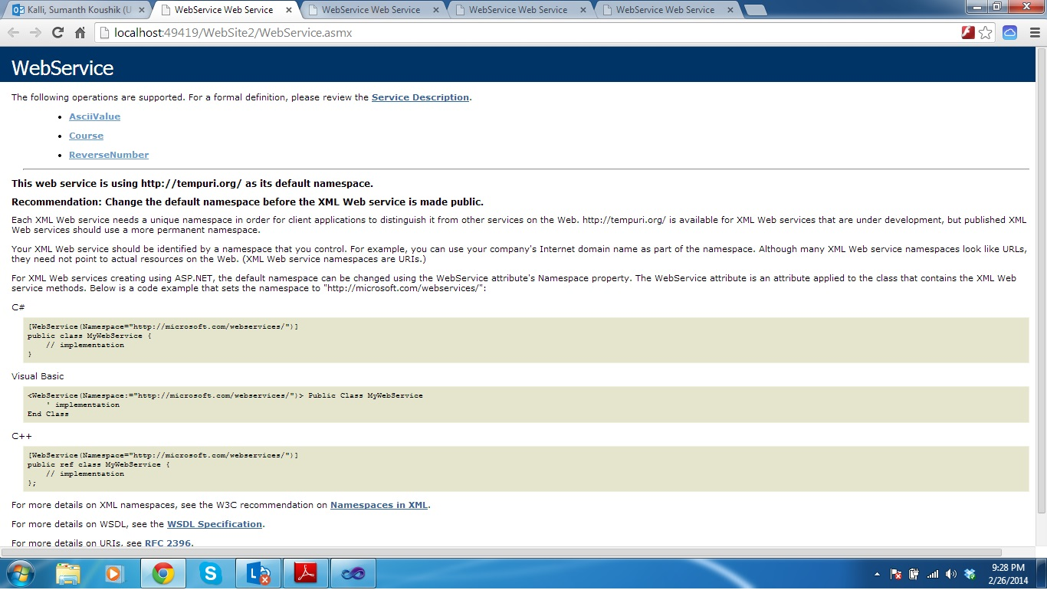

1. In the first part, I have created a web service which takes a character as input and displays it’s ASCII value as output. The Screenshots of the above are given below:

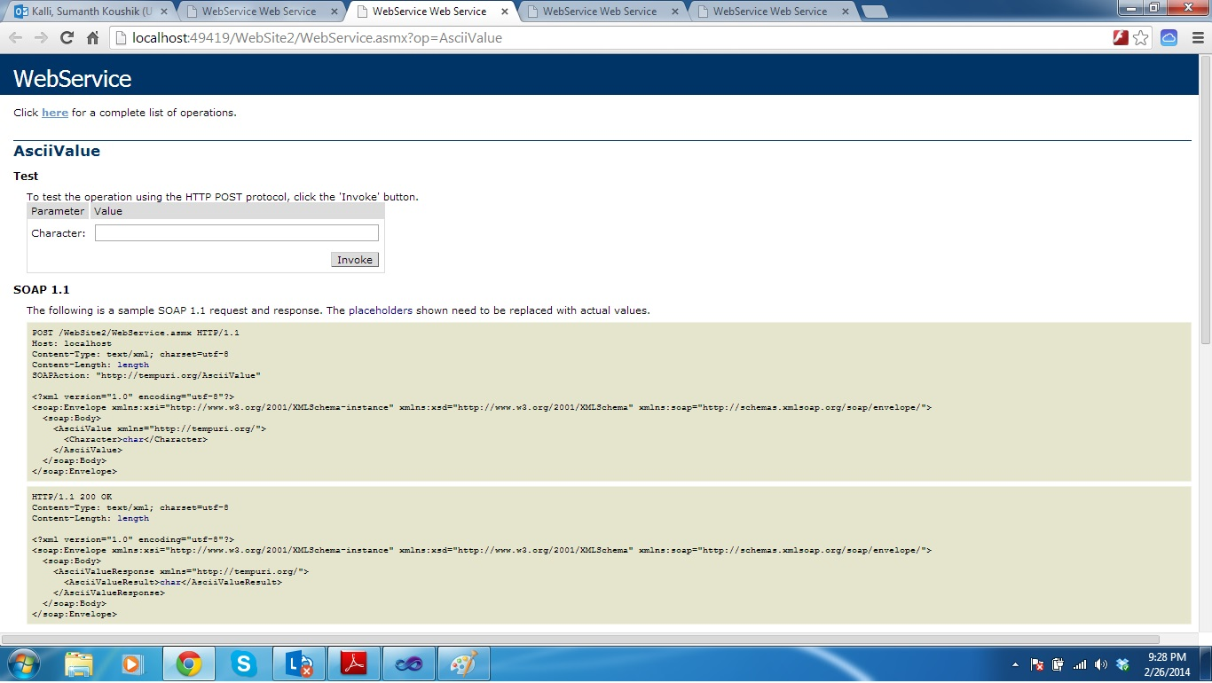

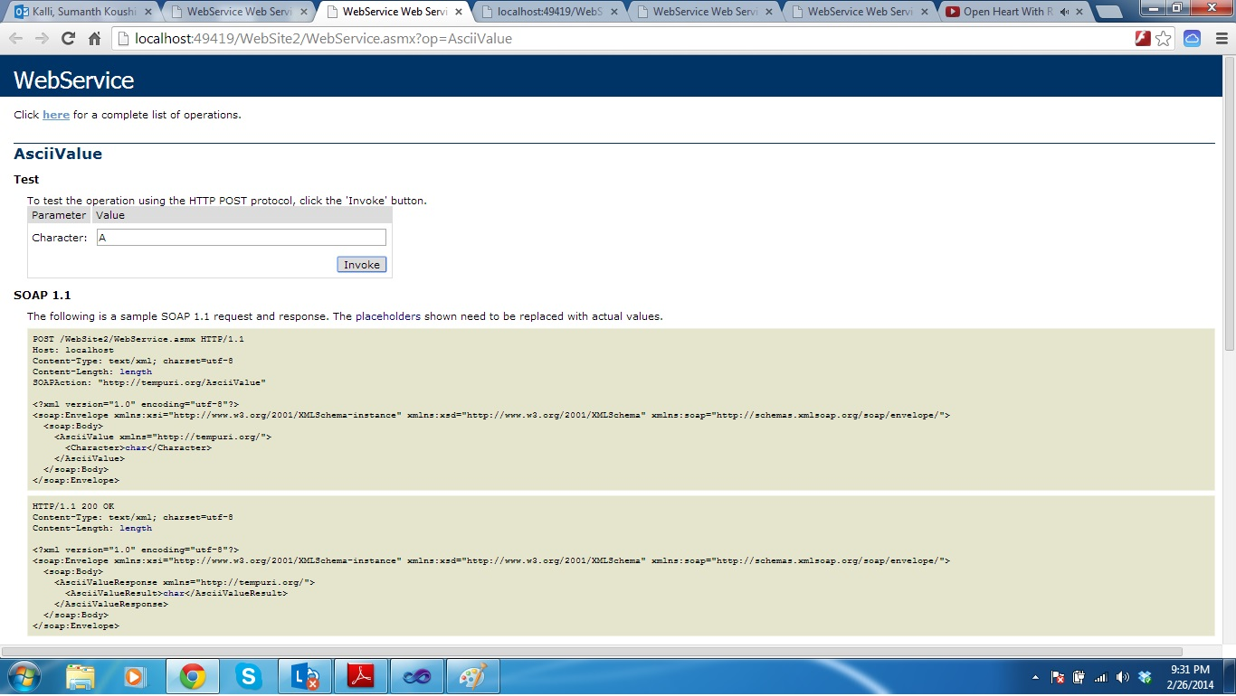

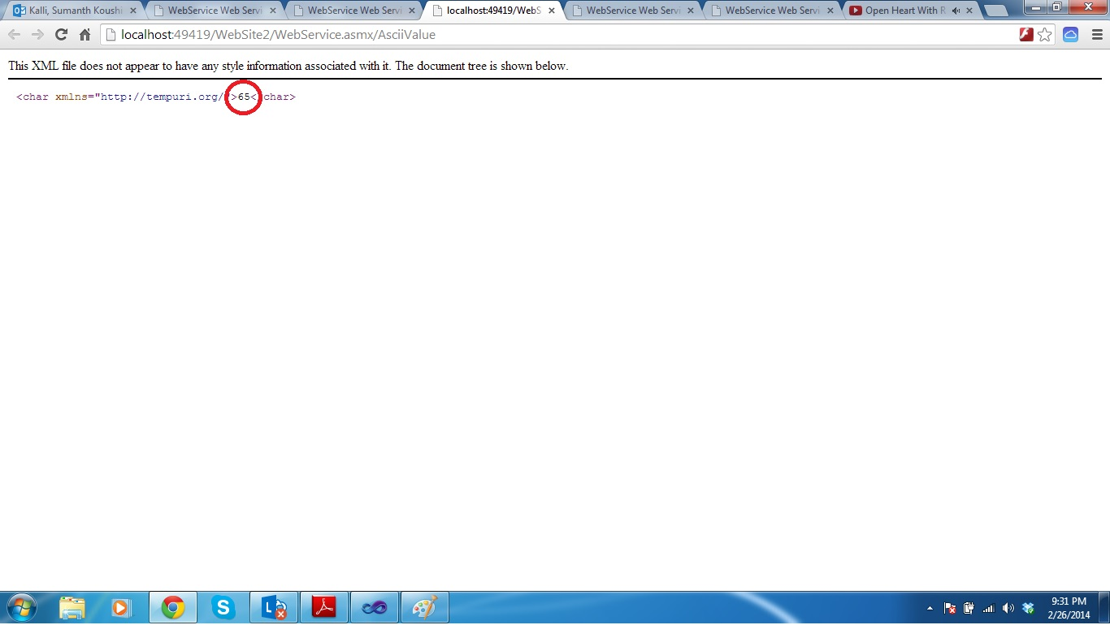

1. In the second part I developed a service which takes our information as input and thought it would be helpful to the project as well. The service displays summarizing the information given as input and is shown below in the screen shots.

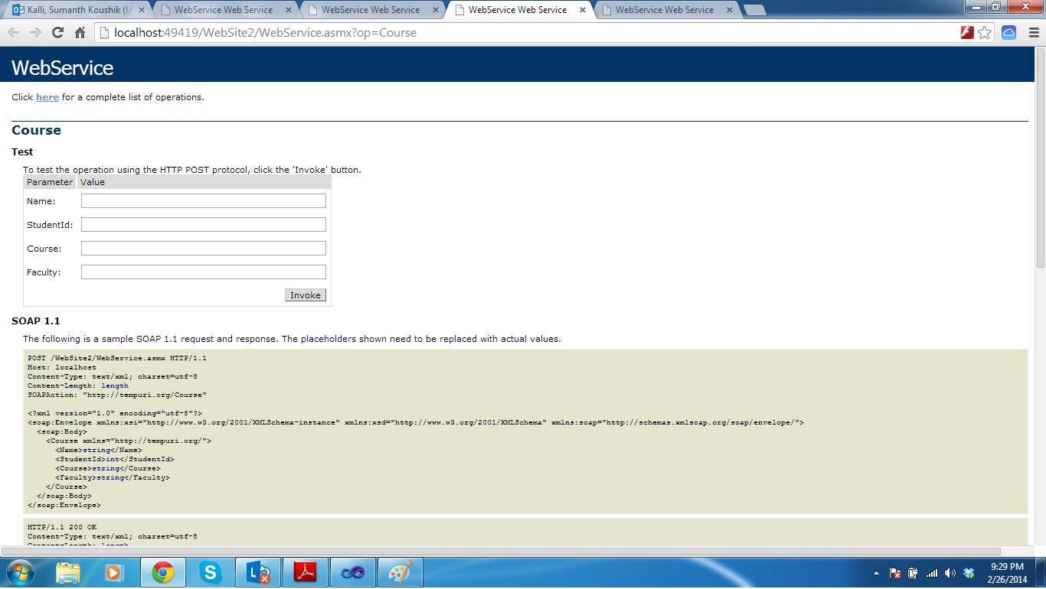

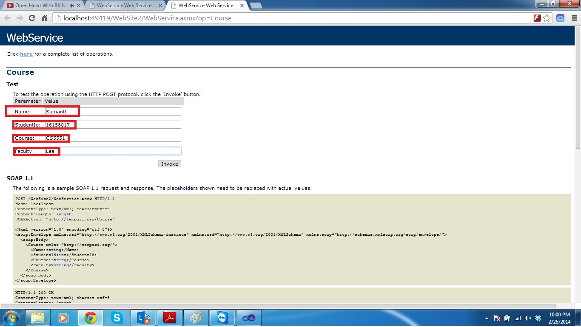

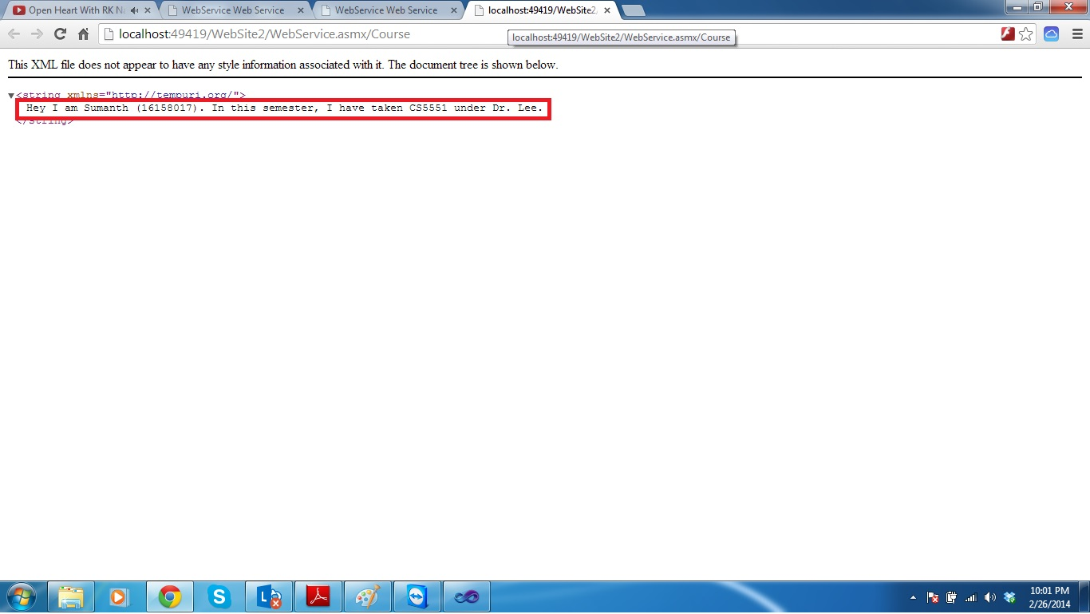

1. In the third part, I have developed a service which takes a number as an input and displays its reverse, which is shown as a screen shot.

